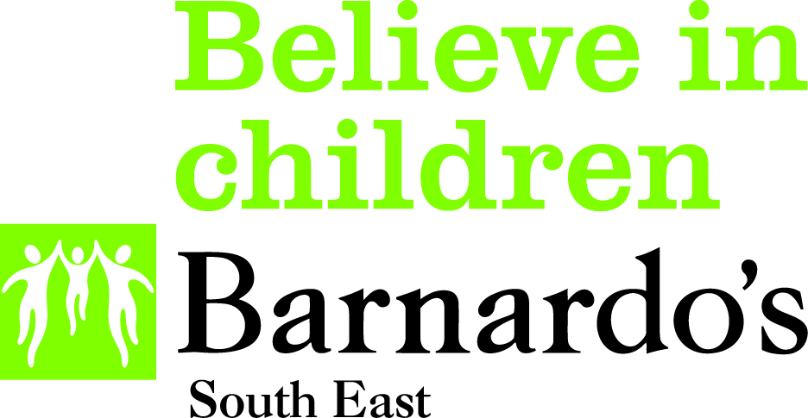

PARENT WELLBEING SERVICE
BARNARDO’S REFERRAL FORM

This form is to be used by anyone referring a parent/carer to the Barnardo’s Parent Wellbeing Service outside of the CAMHS SPA referral pathway.

A. PARENT/CARER INFORMATION
Family Name: |  | Forename/s:
Preferred Name: |  | D.O.B
NHS Number (mandatory): |  | GP Surgery, incl. postcode (mandatory):
Gender:  Preferred Pronouns:  Sexual Orientation: |  |  | Ethnicity:
 |  |  | Religion:
Primary language:  Is an interpreter or signer required?  Y  N  |  | Disability or learning needs (if any):
Does the family have a social worker?
Y  N 

If Yes, please give details:

Address:

Postcode: | Home Phone: |  | Mobile phone:
Email address:

What does the parent/carer think they need support with?

What support do you need regarding your child/young persons mental health?

What would the parent like to achieve from our support?

Has the parent/carer agreed to this referral being made to Barnardo’s? (If no, state reason)
Y  N 

B. CHILD/YOUNG PERSON DETAILS

Child/Young Person Name:

Child/Young Person Address (if different):

Is the child/young person with the Community Wellbeing Team? | Y  N 

D. REFERRER DETAILS
Name of worker completing this referral (Please print)

Agency
Telephone Number
Email Address
Reason for Referral
Known Risks

Other Supporting Information

D. OTHER AGENCIES INVOLVED
Please name key agencies involved with this young person | Phone Number | Email

Please return forms to the Parent Wellbeing Service:

Address: Barnardo’s Parent Wellbeing Service, Barnardo’s Surrey Wellbeing Hub, Regus 107A & 107B, Dorset House, Regent Park, Kingston Road, Leatherhead, KT22 7PL

Email: PWS@barnardos.org.uk

