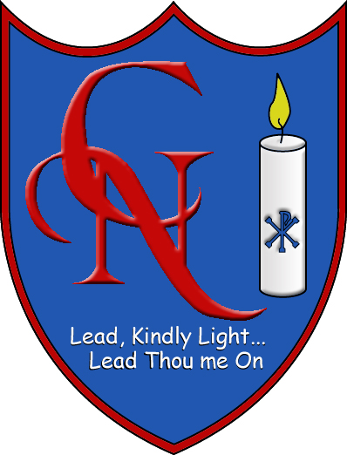 | Cardinal Newman Catholic Primary School  Arch Road, Hersham, Surrey KT12 4QT  Telephone: (01932) 222536 www.cardinalnewmanschool.co.uk  Headteacher: Mrs C Burnham | 

Part-Time Learning Support Assistant
Required ASAP

(hours negotiable, term time only)

We are a welcoming and successful 2-form entry primary school within the Xavier Catholic Education Trust. Our pupils are friendly, well-behaved and eager to learn.

We are looking for someone who:

- Has high expectations of children’s achievement and behaviour
- Has strong interpersonal and organisational skills;
- Is enthusiastic about career development
- Will support the Catholic ethos of our school.

The main duties of the role include :

- Working with small groups and providing 1:1 support for pupils
- Participating with teachers in planning, evaluation and implementation of learning activities and providing feedback on progress and behaviour
- Undertaking short-term class cover
- Supporting the classroom environment (preparing resources, displays, etc.)
- Lunchtime and breaktime supervision

Full-time equivalent salary £21,269
Actual salary will be pro-rata depending on hours

We warmly welcome the opportunity to show you around our lovely school, situated in a convenient location with close proximity to Hersham mainline station and a fast service to London Waterloo. Please contact the school office - office@cardinalnewmanschool.co.uk - to arrange a visit.

Apply for this job either via ETeach or via the school website

Closing date for applications is 18/09/2023 Interviews to take place w/c 25/09/2023

This Trust is committed to safeguarding and promoting the welfare of children, young people and vulnerable adults and expects all staff and volunteers to share this commitment. The Successful applicant will be required to undertake an enhanced check via the Disclosure and Barring Service.

