Science

Electromagnets

As you have been learning over the last couple of weeks A magnet is a special type of object. It produces an area of magnetic force around itself, called a magnetic field. If certain materials enter this magnetic field, they will be attracted to the magnet. This will cause the materials to stick to the magnet.

But what is an electromagnet?

An electromagnet is powered by electricity. It is a temporary magnet that only works when electricity is flowing through a wire.
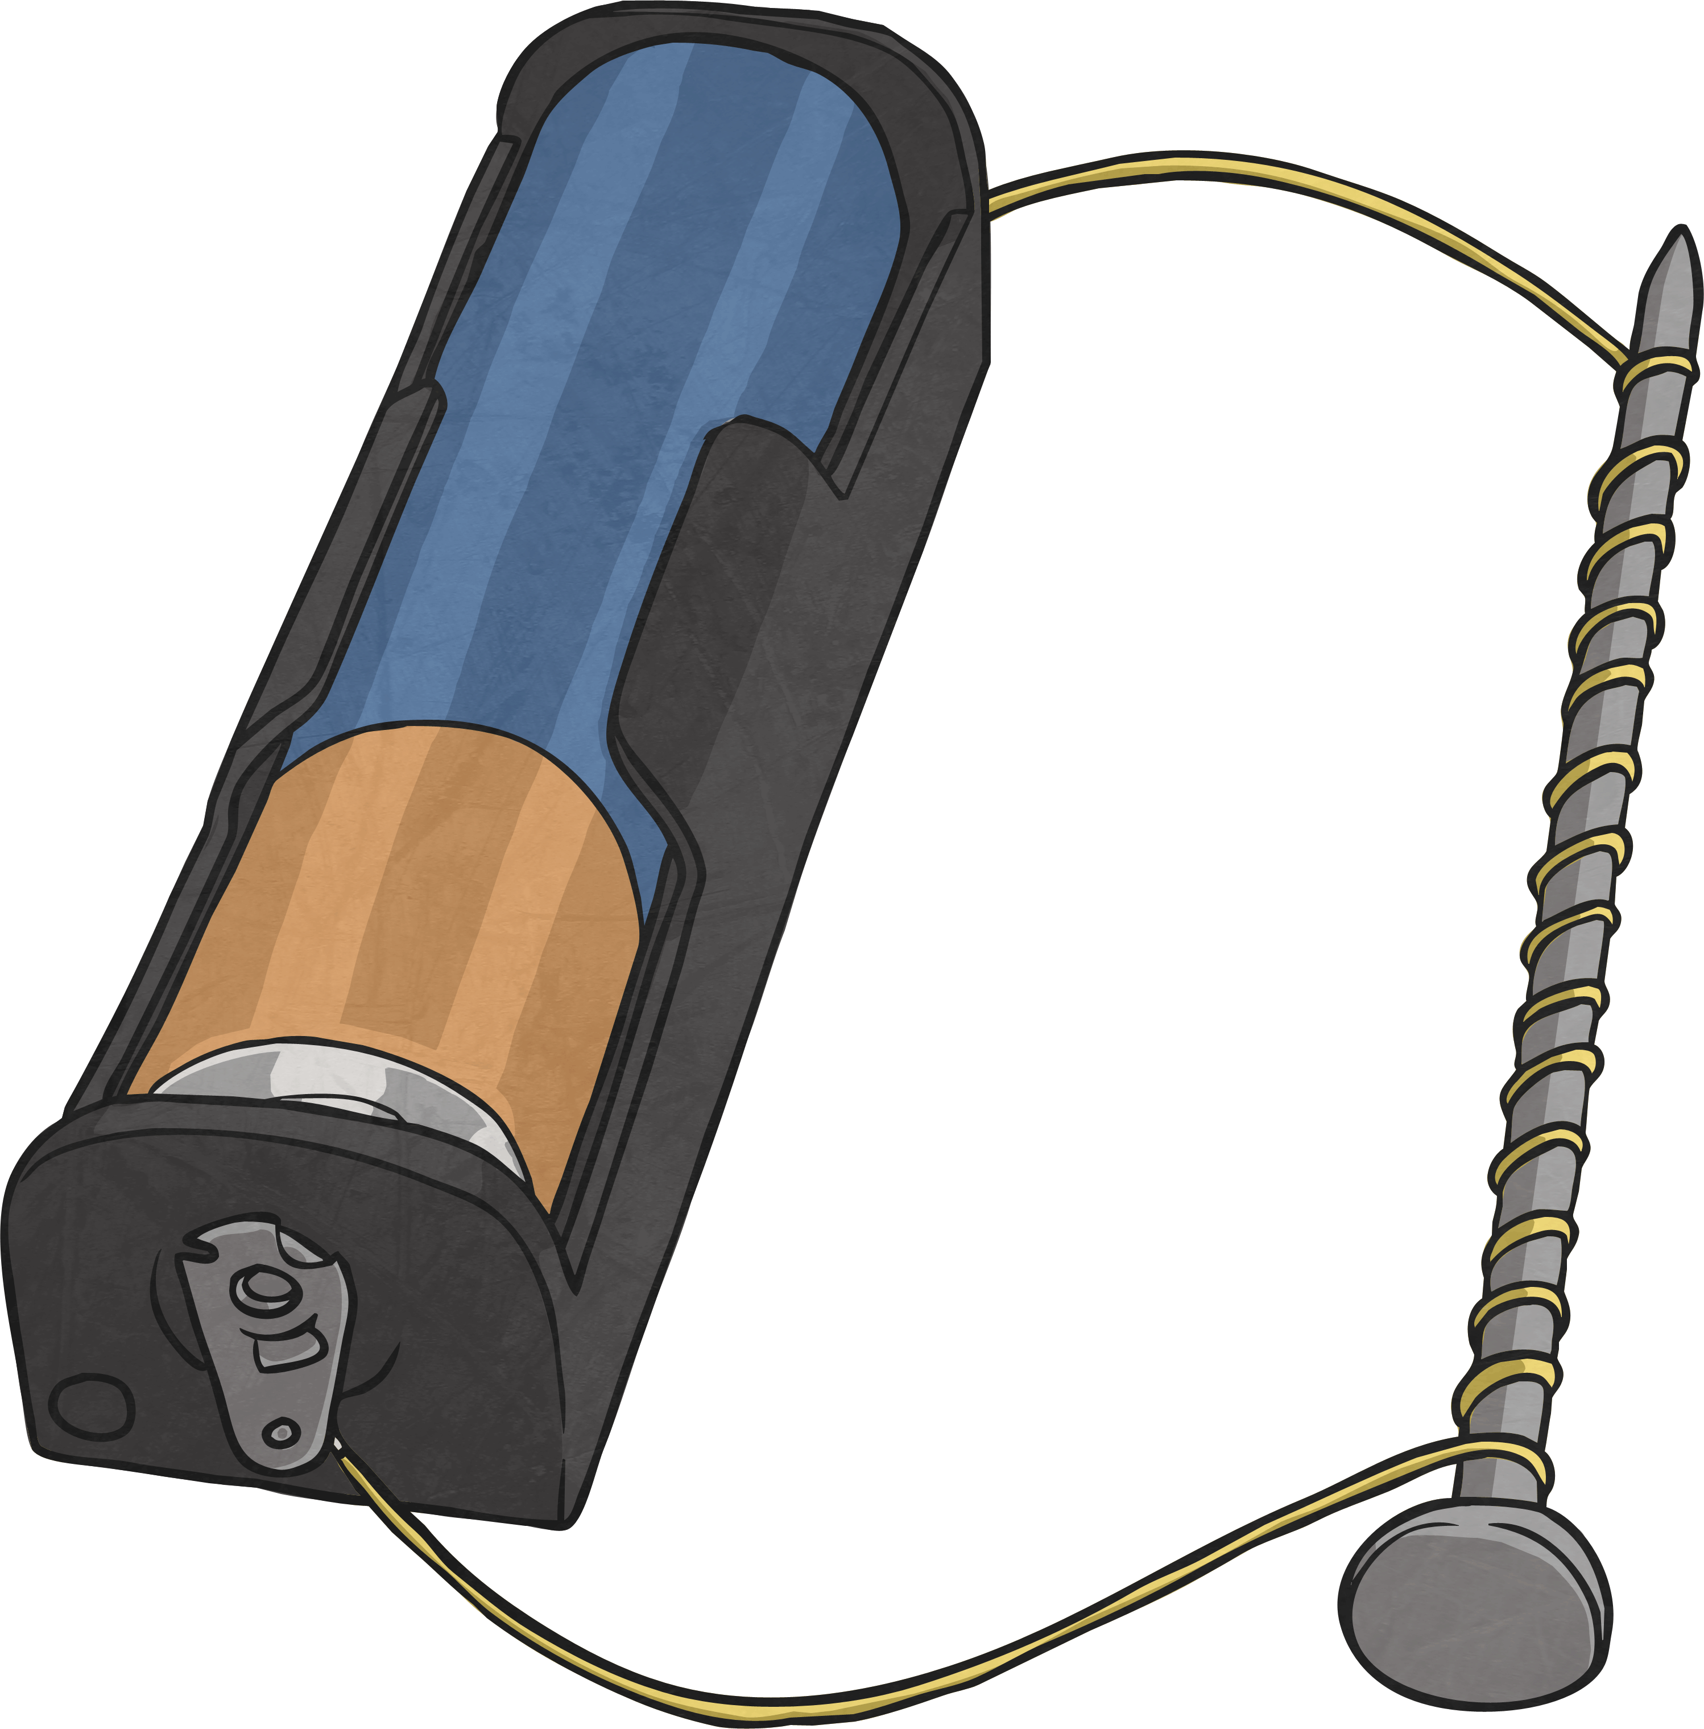
Copper wire is coiled around an iron rod. Both ends of the wire are connected to a power source, such as a battery.
When the wires are connected, electricity flows through the wire. The iron rod and the coils of wire will become magnetised and the electromagnet can be used to attract magnetic materials. When the connection to the power source is broken, electricity no longer flows through the wire and the iron rod and coils of wire lose their magnetism. The electromagnet will not attract any magnetic materials.

The first electromagnets were created in the 1820s. Several scientists helped with the discovery of electromagnetism and developed its use. Other scientists have since refined and adapted the original electromagnets to make full use of their power.

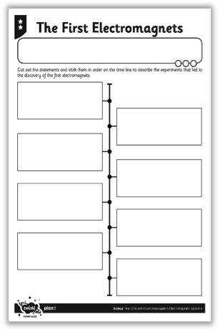
Your task:

Read the information about the important discoveries of various scientists.

Create a timeline on The First Electromagnets Activity Sheet to show when each scientist made their discoveries or completed their experiments.

Stick the statements in the correct order, starting with the earliest in which they happened.

End of Unit Quiz

As we near the end of our work on forces and magnetism, have a go at the quiz which can be found in a PowerPoint presentation on the website. You do not need to answer the questions from memory – carry out some research if you need to, or even test out some of the scenarios for yourself. The answers are at the end for you to check; do try not to take a sneaky peek until you have finished!

You can fill out your answers in the table below.

Good luck!



