CARDINAL NEWMAN CATHOLIC PRIMARY SCHOOL

HOME SCHOOL AGREEMENT
Child’s Name _____________________________________________

Child’s Class __________________________ Date ______________
HOME-SCHOOL AGREEMENT

MISSION STATEMENT
To be a community of learners, believers and friends rooted in the values and teachings of the Gospel. We seek to enable every individual to develop to his or her full potential in the knowledge that they are uniquely created and loved by God.

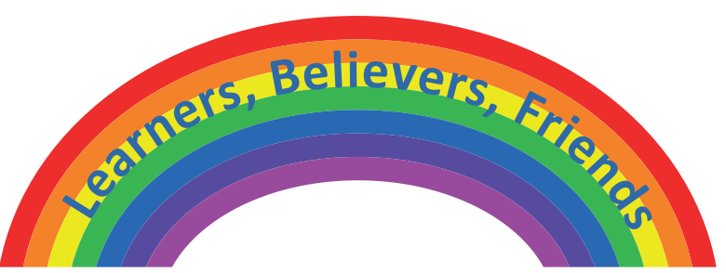

Our Educational Responsibilities as a School

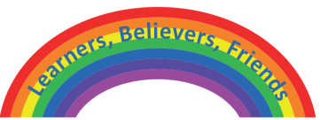 | We believe that you as parents/carers are the first educators of your child and that we are called to support you in your God-given task. We undertake to do our best to provide an education for your child that develops their individual talents, supports their needs and values both their uniqueness and their role in the community. Therefore we will aim to:
- Provide a friendly welcome to you and your child and a secure, stimulating and safe Christian environment in which they can learn

- Ensure that your child is valued, treated with dignity and respect, and encouraged to treat everyone else in this way

- Lead your child by example, demonstrating our Catholic faith and our school’s foundation in the teachings of Jesus Christ, through what we teach and the way we live and worship in our school

- Do our utmost to provide the best possible education we can for your child and enthusiastic teaching rooted in our beliefs, values and our skills to ensure your child makes good progress in religious, spiritual, moral, personal and academic progress

- Provide a balanced and challenging curriculum

- Challenge your child to aim for the highest standards they can achieve and strive for excellence in all they do

- Provide you with information about your child’s progress; with opportunities to talk with teachers about it, and with written reports

- Set appropriate homework for your child

- Inform you of any concerns regarding your child’s behaviour, work or health and contact you if there is a problem with punctuality or attendance

- Treat you and your child with courtesy at all times.

Signed…………………………………………………Class Teacher
Parental Responsibilities

I/We acknowledge that as parents/carers we are the primary educators of our children and have an irreplaceable role to playin supporting our child’s learning at school. Therefore, I/we will try to:

- Support the Cardinal Newman School Mission Statement and the Catholic values of the school community

- Ensure my child attends school regularly and arrives on time to maximize their learning opportunities

- Ensure my child travels to and from school safely eg park safely and with consideration for the school’s neighbours, encourage my child to wear a helmet if cycling

- Follow the uniform code and equipment requests for my child’s class

- Inform the school of any concerns or problems that might affect my child’s work or behaviour

- Support the school’s policies and guidelines for behaviour, security and safety including e-safety

- Give my child opportunities for home learning and support homework from school

- Attend ‘Parent Evenings’ and discussions about my child’s progress

- Encourage my child to be enthusiastic about learning and to enjoy school

- Encourage my child to show kindness, respect and consideration to others

- Talk to my child about their experiences in school and encourage them to do their best

- Read and respond to all communications sent home from school

- Treat every member of the school community with courtesy at all times
- Ensure valuable items are not brought into school. (If such items are brought into school eg mobile phones, the school cannot take any responsibility for loss or damage.)

Name of Child ………………..……………..…. Signed…………………………………….. (Parent/Carer)
Pupil Responsibilities

(To be signed by pupils in Years 3, 4, 5, and 6 only)

I will do my best to:

- Attend school regularly and on time

- Wear my school uniform with pride and bring all the things I need every day

- Take care of all the things our school provides for me to use, and do my part to keep the school tidy and clear of litter

- Think for myself, be honest and take responsibility for my actions

- Use the Internet safely, responsibly and respectfully

- Show good learning behaviours:
- Try my best to achieve my learning and personal targets
- Listen carefully in each lesson and always do my best
- Treat everyone with consideration and respect
- Help make this a safe and happy school for myself and everyone else in school
- Keep our school rules
- Complete and hand in my homework

Signed: ……………………………………… (Pupils in Years 3, 4, 5, and 6 only)

