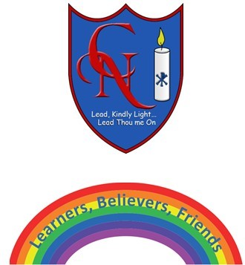
Cardinal Newman Writing Task Reception

Name:

Learning Objective: To write a story using your senses

We are looking for: | Did you remember? (Please tick these 3 boxes below.)
Key words and sounds written accurately
Using good words for what you heard or saw or felt
Capital letters at the start of writing.
Feedback
What you did really well

What you can practice next

Teacher:

