Year 3 Writing Task – Poetry
We know you have all been working hard and trying your best with your home learning. This week we would like you ALL to complete a piece of writing which we will mark and give you some feedback.
We would like you to start your English work this week on Hamilton Week 7, Day 4 as the focus for the writing will be poetry. Do you remember learning and reciting our poems in school? It seems such a long time ago. You need to start the week with the work for Days 4 and 5 and then plan and write your own poem. The work will focus around pets but if you do not have a pet, as we know some of you do not, please write about a pet you might like to own. Really try to be creative and let your imaginations flow.
Remember to start each new line of your poem on a new line, think about using lots of adjectives as well as similes and metaphors. Be brave with your vocabulary choices, use a thesaurus to help you.
You can attempt your writing on the lined paper page that is provided in the Hamilton plan or on your own paper – you may need 2 or 3 pages! You will have noticed when you read the examples that some poems rhyme, but it doesn’t have to rhyme.
At the top of your work we want to see your name, a date and title (all underlined). You will also have a marking sheet – just like the stickers we use in class. When you have finished your poem, try to self-assess (mark) in green against the success criteria, and then ask a member of your family to peer-assess in a different coloured pencil.
If you’d prefer you may type your work, whatever is easiest for you. As you know a good piece of writing takes several days, so don’t worry about days 1, 2 and 3 of Hamilton (Week 7) this week. We are looking for your very best work, so make sure you give it the time it deserves.
Finally, when you have finished, email it to Y3homelearning@cardinalnewmanschool.co.uk by 1st June. If it is handwritten, you could either scan it or take a photo before sending it. Also if you want to really impress us, why not add some illustrations.
We can’t wait to read your poems, as teachers we love reading children’s writing and it is something we have really missed. We will then return the marking sheet to you so you know which aspects of the work you have done well and what your next steps are.
Happy writing!
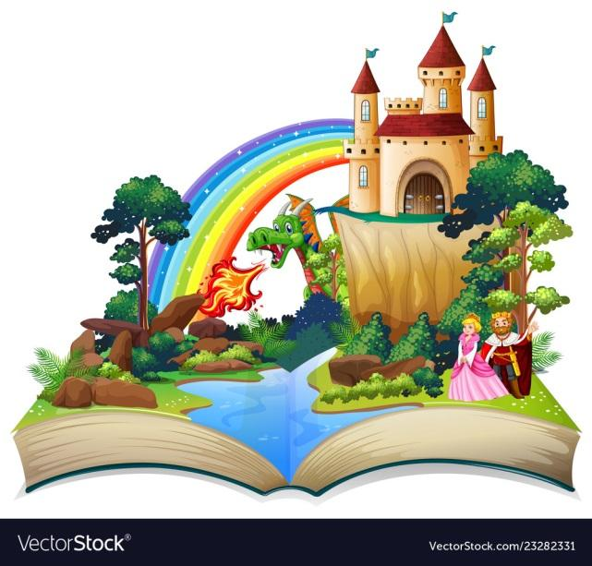
Mrs Mears, Mr Armstrong and Mrs Gautheron

