Reception Writing Task
We enjoyed reading the riddles you wrote last week. Thank you for sending them to us. We had a lot of fun working out the animals from the clues you wrote.
This week we would like you ALL to write a jungle story. We would like use to use your senses when you write your story. What can you see, hear and smell? Remember to use finger spaces, full stops and, if you can, capital letters. We will be excited to hear what you noticed in the jungle and what your jungle animals got up to. Please use the sheet we’ve sent and we will fill it in and send it back to you.
We would like you to write a jungle story.
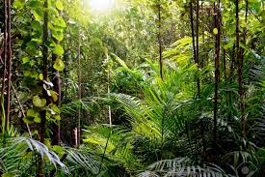
What did the animal see?
What did the animal smell?
What did the animal hear?
Where did he/she go?
What happened to him or her?

