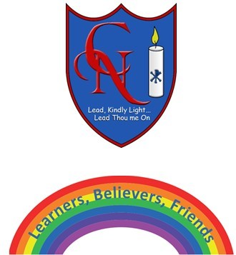
Cardinal Newman Writing Task Year 5

Name:
Learning Objective: To write using description from a different perspective using a range of language features, vocabulary and punctuation

Success Criteria | Self-assessment | Peer assessment | Teacher assessment
I can write using 1st person a detailed description of several objects using creativity from a different perspective
I can make exciting vocabulary choices including interesting noun phrases, adverbial phrases, similes and metaphors
I have included several relative clauses and types of parenthesis to add to and enhance my description

Feedback:

Teacher:

