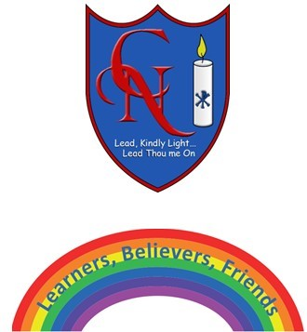
Cardinal Newman Writing Task Year 2

Name:
Learning Objective: To write an information text on rainbows (or something of your choice)

Success Criteria | Self-assessment | Peer assessment | Teacher assessment
I can use full stops and capital letters accurately.
I can use a range of conjunctions to add detail.
I can include key facts from the text.
I can include sub headings in the layout of my writing.

Feedback:

Teacher:

