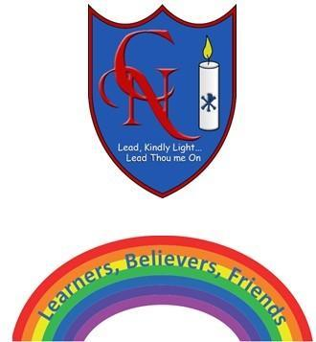
Cardinal Newman Writing Task Year 3

Name:
Learning Objective: To write an information report, All about trolls.

Success Criteria | Self-assessment | Peer assessment | Teacher assessment
I can write an information report using paragraphs and sub headings.
I can use a wide range of adjectives and adverbs.
I can use the full range of punctuation in my writing
Capital letters, full stops, commas, exclamation marks and question marks.

Feedback:

Teacher:

