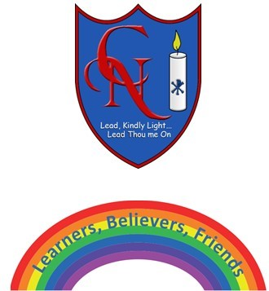
Cardinal Newman Writing Task Summer 2 Week 2 Year 5

Name:
Learning Objective: To write a finding story

Success Criteria | Self-assessment | Peer assessment | Teacher assessment
I have followed the structure of a finding story similar to ‘The Game’
I have included a range of writing features including adventurous vocabulary and at least 2 relative clauses
I have used a sentence of 3

Feedback:

Teacher:

