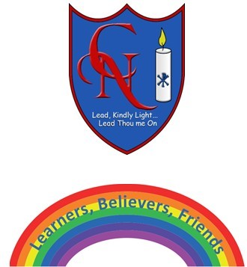
Cardinal Newman Writing Task Year 6

Name:
Learning Objective: To write an imaginative, alternative fairy tale using a range of language features, vocabulary and punctuation

Success Criteria | Self-assessment | Peer assessment | Teacher assessment
I can take a traditional fairy tale and make imaginative and creative changes to it, to grab the interest of the reader
I can make exciting vocabulary choices including interesting noun phrases and adverbial phrases.
I can use the full range of punctuation in my writing
Capital letters, full stops. Commas, exclamation marks, question marks, brackets, apostrophes, colons, semi-colons

Feedback:

Teacher:

