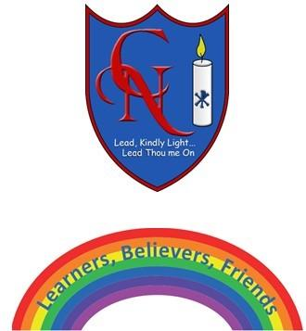
Cardinal Newman Writing Task Year 3

Name:
Learning Objective: To write a character description of a troll.

Success Criteria | Self-assessment | Peer assessment | Teacher assessment
I can write a character description of a troll which grabs the interest of the reader by using a wide and varied vocabulary.
I can use a wide range of adjectives and alliteration, including some 3A sentences.
I can use the full range of punctuation in my writing
Capital letters, full stops and commas.

Feedback:

Teacher:

