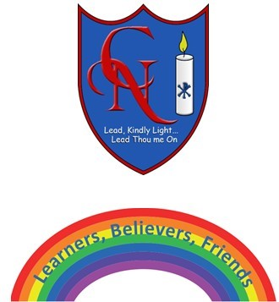
Year 4 Talk for Writing – The Impossibly possible Bookshop

Name:

Learning Objective: To write a poem based on ‘Six things found in a Hobbit’s knapsak’

Success Criteria | Self-assessment | Peer assessment | Teacher assessment
Use prepositions – in the middle, next to, under, below and inside
Create a fun pattern to make your poem easy to remember
Write in shorter lines to slow the reader down

Feedback:-

Teacher:

