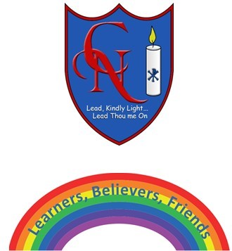
Cardinal Newman Writing Task Year 1

Name:
Learning Objective: To write a new story with new characters.

Success Criteria | Self-assessment | Peer assessment | Teacher assessment
I can use capital letters and full stops accurately.
I can make my letters sit on the line and use my best cursive handwriting.
I can use interesting adjectives.
I can use a variety of conjunctions (because, and, but, so).

Feedback:

Teacher:

