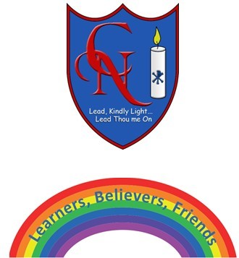
Year 4 Talk for Writing – Mission Impossible

Name:

Learning Objective: To create interesting character profiles.

Success Criteria | Self-assessment | Peer assessment | Teacher assessment
I can use different techniques to develop characters for a story.
I can use descriptive vocabulary to describe different characters.
I can magpie character ideas from my favourite books.

Feedback:-

Teacher:

