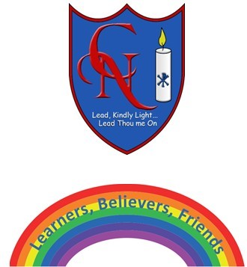
Cardinal Newman Writing Task Year 1

Helping Sydney to improve his punctuation and handwriting.
Name:
Learning Objective: To use capital letters and full stops accurately.

Success Criteria | Self-assessment | Peer assessment | Teacher assessment
I can begin each sentence with a capital letter.

I can use a capital letter for the name of a person.

I can end each sentence with a full stop.

I can make my letters sit on the line and use my best cursive handwriting.

Feedback:

Teacher:

