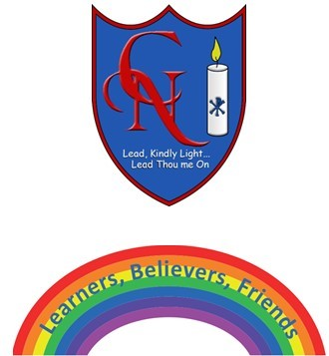
Cardinal Newman Writing Task Year 2

Name:
Learning Objective: To create a fact sheet about the symbolism of rainbows.

Success Criteria | Self-assessment | Peer assessment | Teacher assessment
I can plan and create a non-fiction fact sheet/web page.
I can organise my writing in sections.
I can use illustrations to provide extra information.
I can use correct punctuation.

Feedback:

Teacher:

