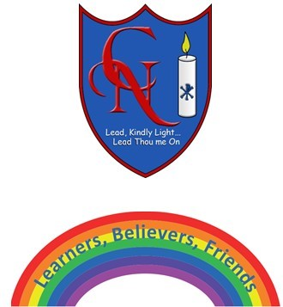
Cardinal Newman Writing Task Year 4

Name:
Learning Objective: To write a descriptive story, using a range of exciting vocabulary and accurate punctuation.

Success Criteria | Self-assessment | Peer assessment | Teacher assessment
I can write a narrative with a clear structure, setting, characters and plot.
I can use a range of sentences with more than one clause.
I can evaluate and edit my own work for improvements.

Feedback:

Teacher:

