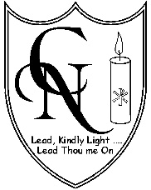
CARDINAL NEWMAN SCHOOL
WHIZZ KIDS CLUB APPLICATION FORM
The Breakfast Club runs Monday to Friday and will be open from 7.50 am until 8.40 am term time only. Breakfast will be provided if required. The cost per session (including breakfast) is £5.50 for full time children and £6.50 for ad hoc bookings. An earlier drop off time of 7.30 am is available at a cost of £7.50 per session.
The After School Club runs Monday to Friday 3.20pm to 6.00pm term time only. The cost per session (including snack) is £11.50 for full time children and £12.50 for ad hoc bookings
Child’s Details: (1 form per child to be completed)
Name | DOB | Age | Male/  Female
Parent/Carer/Guardian Details:
(please remember to let us know of any changes)
Full Name:
Address:
Email:
Telephone numbers (please indicate the main number to contact you)
Home:
Work:
Mobile:
Other Contact Details:
(please provide the details of 2 other people in case we cannot contact you)
Name: | Telephone Number:
Permanent Sessions: (please tick which days you require)
 | Mon | Tues | Wed | Thurs | Fri
Breakfast Club
After School Club

Starting date: ………………………………………….

I confirm I have read the Club terms and conditions (please tick)
Forms to be returned to the school office or emailed to wraparoundcare@cardinalnewmanschool.co.uk
We will contact you to confirm if we are able to offer a place

Signed : ………………………………………………………………………… Date: ………………………………….

