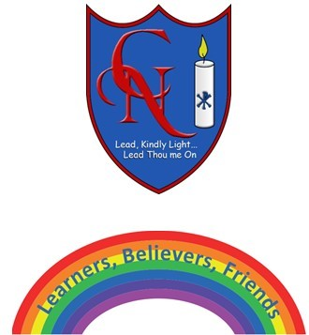
Cardinal Newman Writing Task Year 2

Name:
Learning Objective: To write a character description of my own ‘Superhero’ using adverbs and expanded noun phrases to add detail.

Success Criteria | Self-assessment | Peer assessment | Teacher assessment
I can use full-stops, capital letters, commas and exclamation marks correctly, if needed.
I can use expanded noun phrases to describe my Superhero.
I can use adverbs to describe how my character moves and speaks.
I can describe their appearance, special powers and personality.

Feedback:

Teacher:

