Managing Behaviour Effectively for
Parents & Carers
No one has ever said parenting was easy. Living with children can be one of life’s most enjoyable experiences, but it can also be unbelievably frustrating. 123 Magic is a simple, precise and effective way of managing the behaviour of children. It’s not magic but works like magic!

The aims of the programme are:-

Job 1: Controlling Challenging Behaviour – Learn an amazingly simple technique to get children to STOP doing what you don’t want them to do (whining, arguing, tantrums, sibling rivalry etc.).
Job 2: Encouraging Good Behaviour – Learn several effective methods to get your children to START doing what you want them to do (picking up, eating, going to bed and staying there! chores etc.).
Job 3: Strengthening Your Relationship – Learn powerful techniques that reinforce the bond between you and your children and build good self esteem.
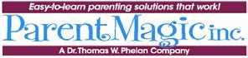
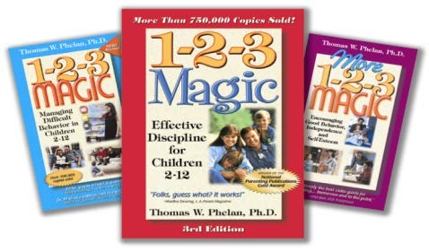
Will the programme work with children who have learning difficulties? It certainly can. The program has been used successfully with Autistic, Asperger's, ADHD and ODD children. In fact when parents have children with these difficulties, the clarity of the 123 Magic warnings is especially helpful for the visual and auditory understanding.

The course is a 4 week programme and the following courses available are as follows:-

Tuesday 7th, 14th, 21st & 28th November (4 weeks) 9.15am – 11.15am at Cardinal Newman School, Arch Road Hersham KT12 4QT

If you would like to book onto the course please contact Michelle Talboys - Home School Link Worker on 07703 322066 or email at hslw@thames-ditton-infant.surrey.sch.uk

