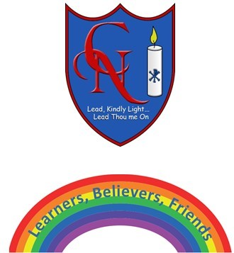
Cardinal Newman Writing Task Year 2

Name:
Learning Objective: To plan and write a story based on ‘Wild Pets’

Success Criteria | Self-assessment | Peer assessment | Teacher assessment
I can use full stops and capital letters accurately.

My story has a clear beginning, middle and end.
I can use expanded noun phrases to add detail.
I can use similies in my writing to add detail.
I can use different adverbs to start my sentences.

Feedback:

Teacher:

