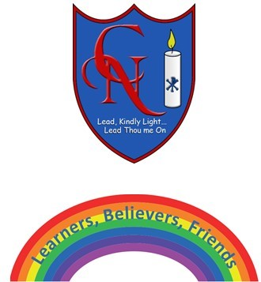
Cardinal Newman Writing Task Reception

Name:

Learning Objective: To write an imaginative story about what your toy did at night.

We are looking for: | Did you remember? (Please tick these 3 boxes below.)
Key words written accurately
Using all the sounds you can hear in a word
Finger spaces

Feedback
What you did really well

What you can practise next

Teacher:

