A message from Talk for Writing
Please donate to Great Ormond Street Hospital Children’s Charity if you use this resource.
Dear Teacher/Parent/Carer,
Welcome to the third batch of home-school unit booklets!
The first two batches of units have reached hundreds of thousands of children and the positive feedback has been overwhelming.
PLEASE DONATE!

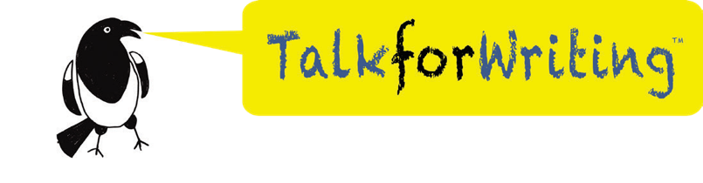
The units are intended to be used with online support by class teachers and by parents at home. They are produced by unpaid volunteers who are giving their time to help teachers, families and children while the schools are closed and we want to use the units to help an extremely good cause.
We are asking for voluntary contributions to Great Ormond Street Hospital of:
- £5 per year group unit
Schools using or sending the link to a unit to their pupils
- £2 per unit
Parents using a unit with their child, if they can afford to do so
Every single penny raised will go directly to Great Ormond Street Hospital. Due to Covid-19, the hospital has increased its intensive care capacity to make sure they have room for some of the UK’s most seriously ill children. They need support now more than ever to give these children a better future.
DONATE HERE
www.justgiving.com/fundraising/home-school-booklets
I hope you enjoy using the unit. Thank you for your support. With best wishes,

Pie Corbett
Talk for Writing

What is Talk for Writing?
Thousands of schools in the UK, and beyond, follow the Talk for Writing approach to teaching and learning. Find more about it here.

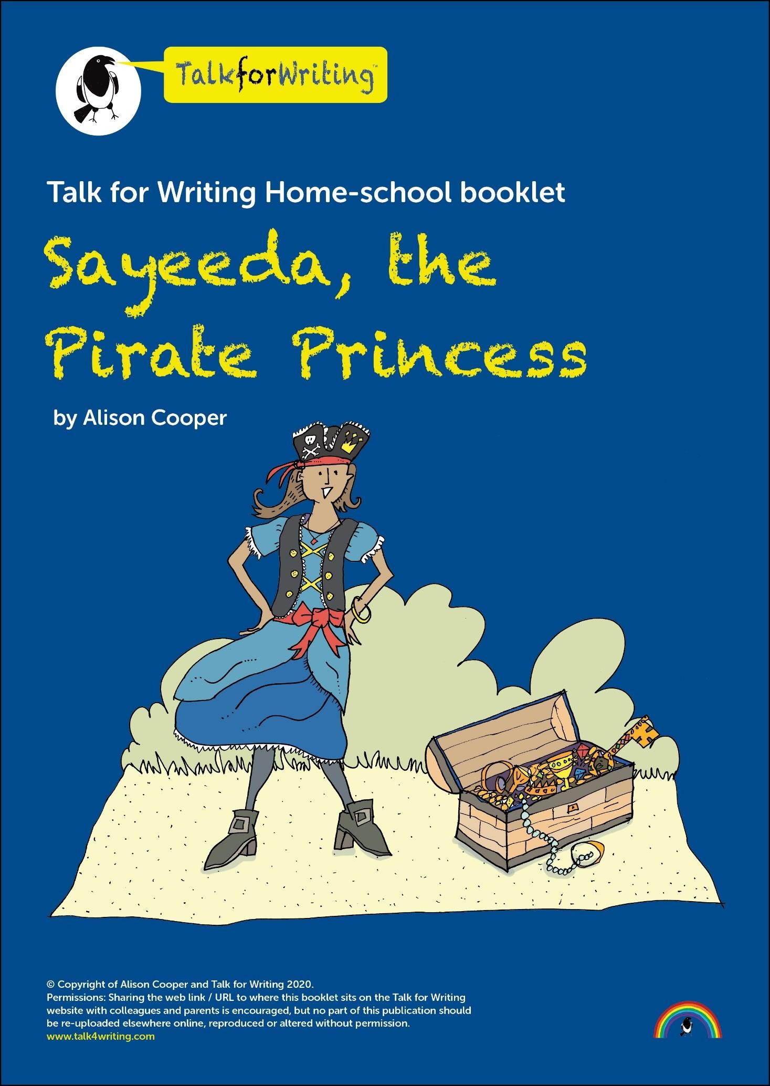

Dear Parent/Carer,

Thank you for taking time to support your child with their learning. This booklet is designed to inspire and support your child to develop skills and confidence in English – speaking, listening, reading and writing.
Through the world of Sayeeda, the Pirate Princess, your child will explore a range of purposeful activities which are broken down into bite-sized chunks. Each activity is carefully explained and many could be extended. They are designed to be shared activities. At the end of the booklet, you and your child and are invited to comment on how they got on with the learning and this will help their class teacher.
The activities in this booklet are:

- Story of Sayeeda the pirate princess
  - Talk activity about the story
- Reading response activities
  - Who said what?
  - Quiz Time
- Exploring words together
- Enjoying a song together: ‘When I was one.’
- Fill your treasure chest
- Sayeeda’s diary entry: helping her to use fullstops and capital letters
- How to make a pirate hat
- Story time!
- What’s in Fergus’ treasure box?
- Riddles
- Treasure maps
- Review of learning

Have fun together!

You can listen to an audio version of this story here: https://soundcloud.com/talkforwriting/sayeeda/s-ewAQuMNjrJt

Sayeeda, the pirate princess
Once upon a time, there was a pirate princess called Sayeeda who lived on a pirate galleon with her pirate family. Sayeeda loved to spend her days looking at all the beautiful treasure the pirates had stolen as they sailed the seven seas. There were golden brooches, pearl rings and ruby bracelets but, most of all, she loved to open her very own treasure box.
One breezy, sunny morning, Sayeeda sat on deck with the treasure box in her hands. “Don’t open your treasure box on deck,” warned her father. “It’s a breezy morning and the galleon might hit a big wave and your treasure will roll out.” Sayeeda didn’t listen.
Carefully, very carefully, she lifted the lid and took out a beautiful
jewelled key, her favourite. She lifted it to her neck but….
“Whoosh…sh…sh...sh!” The galleon rocked to and fro, fro and to and a huge wave swept over the deck. “Whoosh…sh…sh…sh!” Sayeeda held on tightly to the rail but the jewelled key slid from her hands. Down, down, down it sank into the deep, dark sea. Sayeeda wept.
Luckily, a dolphin passed by and heard Sayeeda weeping. “Jump onto my back and hold my fin,” he said. “We’ll dive down and try to find it. “So, they swooped and they swooped through the water. Unluckily, there was no sign of the jewelled key. Sayeeda climbed back onto the pirate galleon and wept again.
Next, a whale passed by and heard Sayeeda weeping. “Climb onto my head in front of my blow hole,” she said. “We’ll glide across the sea and look down through the clear ocean water and try to find it.” So, they swished and swashed gently across the water. Unluckily, there

was no sign of the jewelled key. Sayeeda climbed back onto the pirate galleon and wept even more.
Finally, a seagull landed on the deck beside Sayeeda. “Jump onto my back and hold my wings,” he said, “We’ll fly across the sea and try to find it.” So, they flew high through the gentle breeze and all the
seagulls’ friends joined them. They flew and they flew until they came to a beach and Sayeeeda jumped off the seagull’s back. She took a few steps across the sand and … there in front of her was a jewelled key. Her key. “Oh, thank you,” said Sayeeda to the seagull. Together, they flew back to the pirate galleon.
Sayeeda locked the key safely in her treasure box. Then she took the box to her cabin and locked it away in her cupboard. She remembered her father’s warning. Never again, would she open her treasure box on the deck.

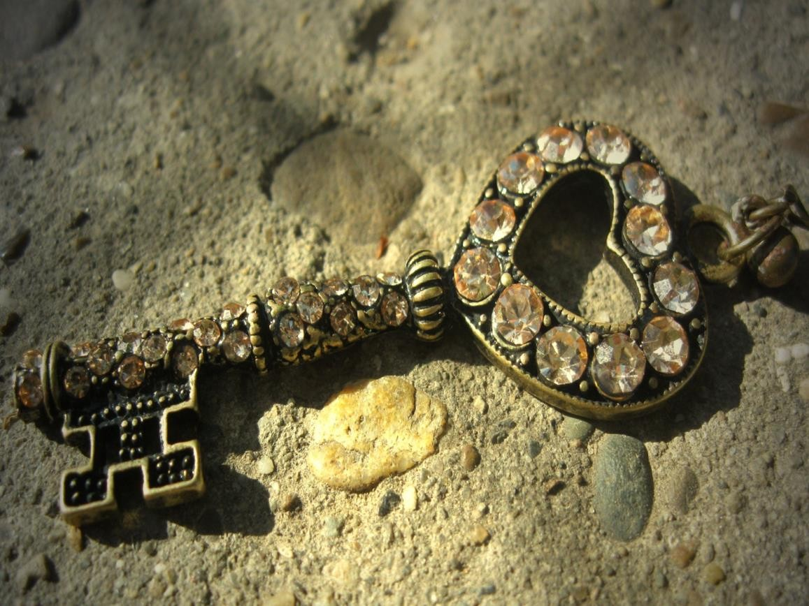

Talk about the story
Share the story of Sayeeda, the Pirate Princess with a grown-up and talk together about the story. Then fill in Sayeeda’s sticky notes.

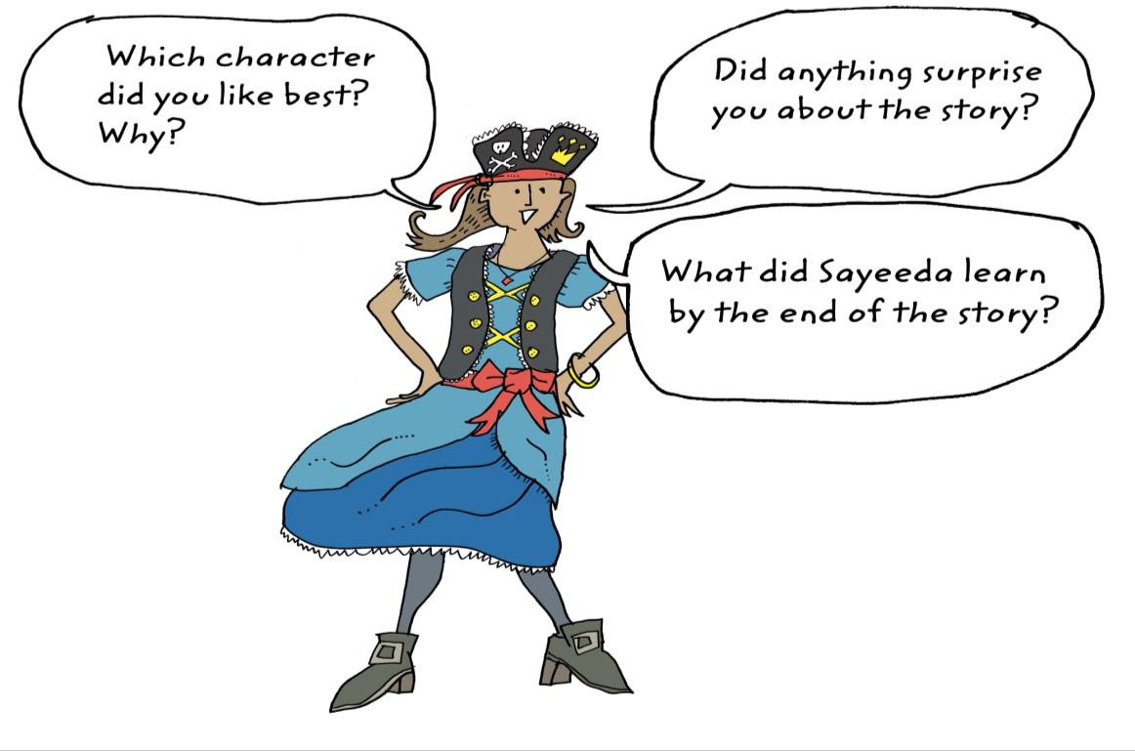

Who said what?
Read the story together again.
Draw a line to match the speaker with the correct image.

“Jump onto my back and  hold my fin.” | 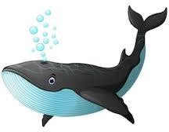
“Jump onto my back and hold my wings.” | 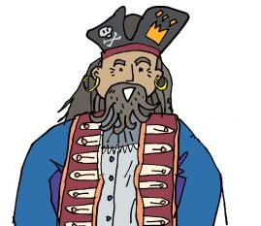
“Thank you.” | 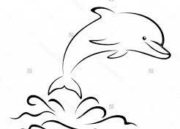
“Climb onto my head in front of my blowhole” | 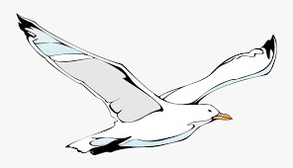
“Don’t open your treasure box on deck.” | 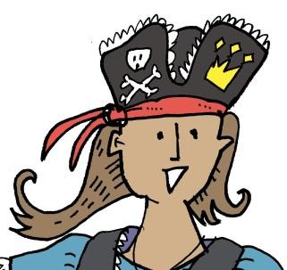

Quiz time

- How did Sayeeda like to spend her days?

- What did she like to do best?

- Why did Sayeeda’s father tell her not to open her treasure box on the galleon’s deck?

- What do you think Sayeeda’s father said to her when the jewelled key slid away?

- Why did Sayeeda weep?

- What happened to the jewelled key when it slid from
Sayeeda’s hands?

- What lesson did Sayeeda learn by the end of the story?

Exploring words together

Here are some words from the story. Can you share them with an adult to work out

Say the words slowly, quickly, softly, loudly and in as many different ways you can.
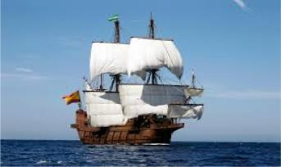
Show your grown up how you can
swoop … glide … fly
like the creatures in the story.
A
ship with sails used a very long time ago.
galleon
breeze
a gentle wind

Sing along!
Sayeeda and her family love to sing this song. Can you join in?
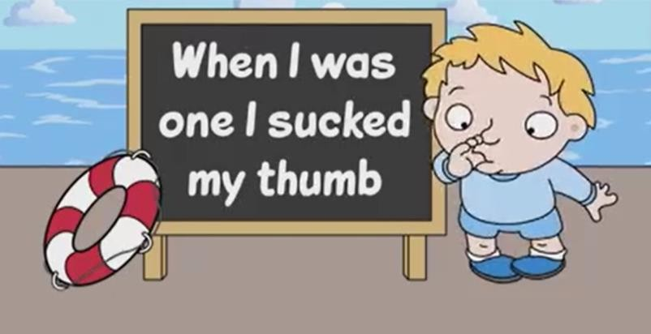
Here’s the first verse
When I was ONE I sucked my thumb, The day I went to sea.
I jumped aboard a pirate ship, And the captain said to me –
We're going this way, that way, Forwards and backwards,
Over the Irish Sea,
We're going this way, that way, Forwards and backwards, That's the life for me!

(Anonymous – that means no one knows who wrote it.)
You can find the rest of the song here:
https://www.bbc.co.uk/teach/school-radio/nursery-rhymes-when-i-was-one-i- sucked-my-thumb/zhbyt39

Fill your treasure chest

What would you put into your treasure chests? Choose at least 6 items to describe and explain why they are special to you or why you have chosen them. E.g In my treasure chest I would have a ……….because…..

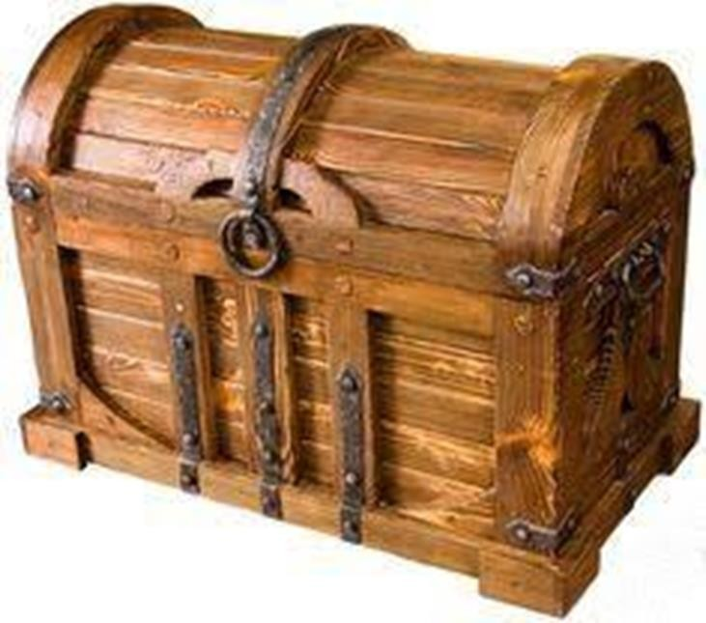

Diary writing

Last night I wrote in my diary about my adventure but I couldn’t remember where to put the capital letters and full stops. Please can you correct the letter for me using a coloured pencil?

Dear Diary,
yesterday I had an adventure I was on the deck and I was holding my beautiful jewelled key all of a sudden a huge wave swept it from my hands and it fell overboard daddy said, “Shiver my timbers!” and I cried
luckily, a seagull helped me to find my key and daddy gave me a hug it was fun flying on the seagull’s back
I have locked my treasure box in my cupboard and I
won’t take it on deck again bye for now
sayeeda xxx

How to make a pirate hat
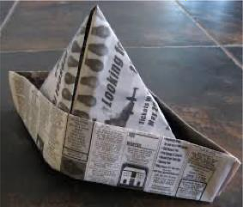
My hat fell off when I swooped along on the dolphin. Can you make a new one for me?

My hat fell off when I swooped along on the dolphin. Can you make a new one for me?

What you need:
One sheet of newspaper
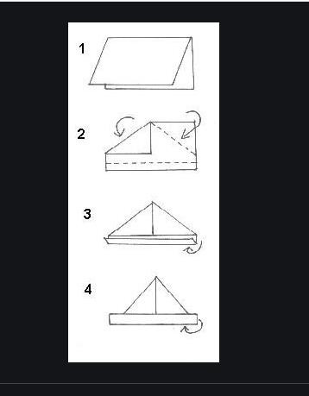
What you do:
- Fold the paper in half.
- Fold over the top corners so they meet in the middle.
- Lift up the flap facing you and fold in.
- Turn the hat around.
- Now lift up the other flap and fold in.
- Decorate my hat.

What’s in Fergus’s treasure box?
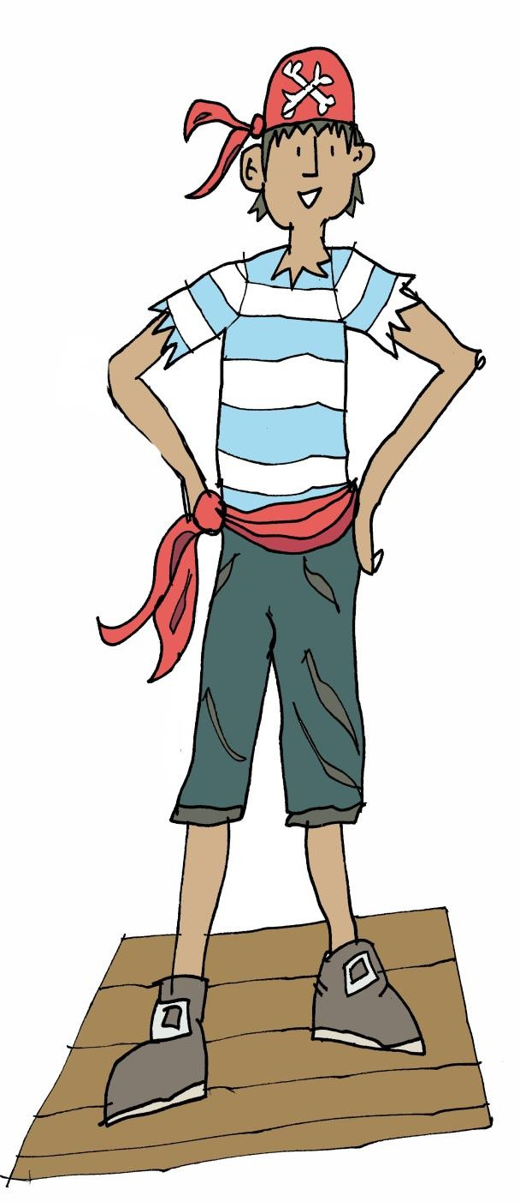
Read the poem Fergus has written

My treasure box

In my treasure box I keep:

A dried starfish washed up on the beach.
A pearly pink conch shell
An emerald wing feather from Pebbles the Parrot.
Six golden coins.
A mermaid’s purse. Blackbeard’s ruby ring. Eight pirate sweets.

Now you’ve read the poem, can you solve my riddles?
I belonged to Bluebeard.
What am I?

I was washed up on a
beach.
What am I?

You can spend us in a shop?
What are we?

I fell out of pebbles. What am I?

I am pearly pink. What am I?

There are eight of us and you can eat us.
What are we?

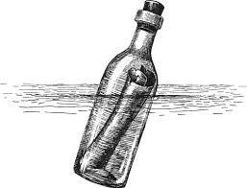
Message in a bottle
Today, I found a bottle floating in the sea. Inside was this message.

Today, I found a bottle floating in the sea. Inside was this message:
My sister and I are trapped in a cave on bounty island. Please can you rescue us? BEWARE, Pirate Greeneyes is guarding us!
From
Sam and Polly
Now write a reply from Sayeeda to Sam and Polly.

Treasure maps!
Can you make a treasure map with your grown up?
This web link will help you.

https://theimaginationtree.com/diy-pirate-map-and-treasure-hunt-games/
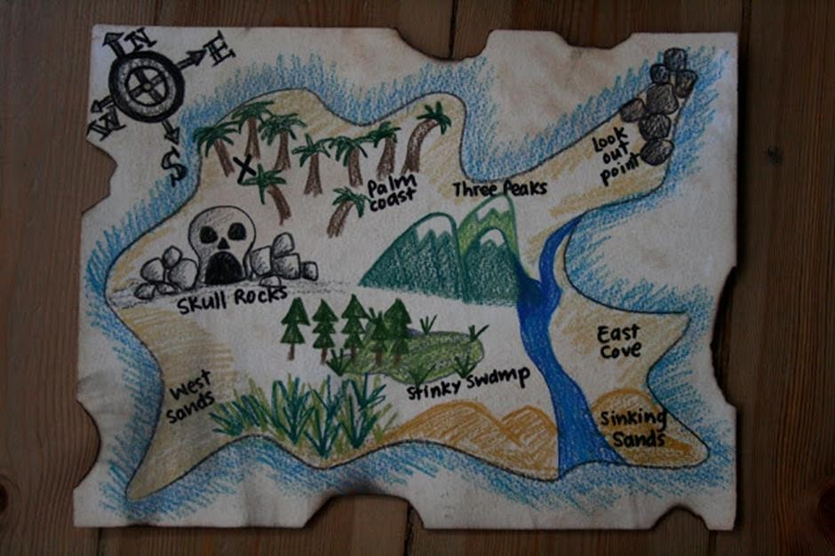

When you've made your map, can you make up a story about hunting for treasure?

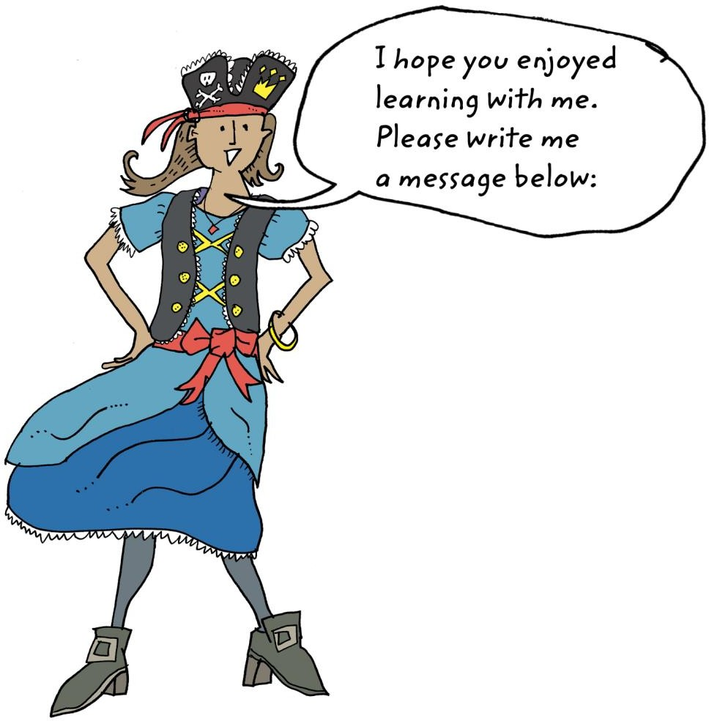

The activities I liked best were……………….
…………………………………………………………….
I’ve learned…………………………………………..
……………………………………………………………..
My grown up thinks………………………………
……………………………………………………………..
……………………………………………………………..

© Alison Cooper for Talk for Writing
Alison Cooper, former teacher and Regional Adviser for Primary English with the National Strategies, now works with Talk for Writing to help schools develop the approach.
Edited and designed by Julia Strong
Prepared for online distribution by Nick Batty

To find out more about Talk for Writing, visit www.talk4writing.com.

Thanks to Jon Ralphs for the cartoons: jonralphs.com
Permissions: Sharing the web link / URL to where this booklet sits on the Talk for Writing website with colleagues and parents is encouraged, but no part of this publication should be uploaded elsewhere online, reproduced or altered without permission.

