Reception Writing Task
We hope your special person enjoyed their descriptions. Make sure you read it to them. You did really well and made us smile. We are seeing lots of very good handwriting, don’t forget to join up the letters in your key words. You have practised writing them joined up. Remember: There will be a question mark at the end of the sentences in your riddle.
This week we would like you ALL to write a riddle about a jungle animal of your choice. We are looking forward to seeing if we can guess which animal it is.

We would like you to write a riddle about a jungle / wild animal. This is our riddle for you.
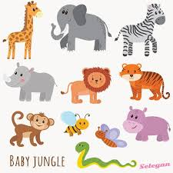
I have a trunk.
I am grey.
I have 4 legs.
What am I?

