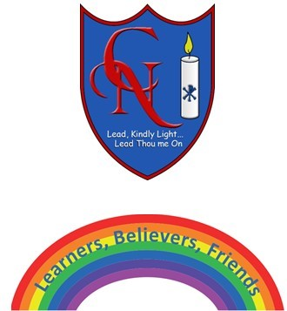
Cardinal Newman Writing Task Summer 2 Week 3 Year 5

Name:
Learning Objective: To include adventurous vocabulary in a short wishing story

Success Criteria | Self-assessment | Peer assessment | Teacher assessment
I have followed a similar structure to model wish story
I have included 10-15 new vocabulary from the week’s exercises and checked they suit
I included a variety of descriptive writing tools including noun phrases, adverbials and figurative language

Feedback:

Teacher:

