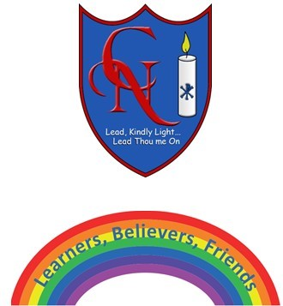
Cardinal Newman Writing Task Reception

Name:

Learning Objective: To write a riddle

We are looking for: | Did you remember? (Please tick these 3 boxes below.)
Key words written accurately
Using all the sounds you can hear in a word
Question marks

Feedback
What you did really well

What you can practice next

Teacher:

